SQL ASSESSMENT-1

TOPICS: **Execute all the join with examples.**

**STEP 1: Using Database “sqlassessment” and values from the tables.**

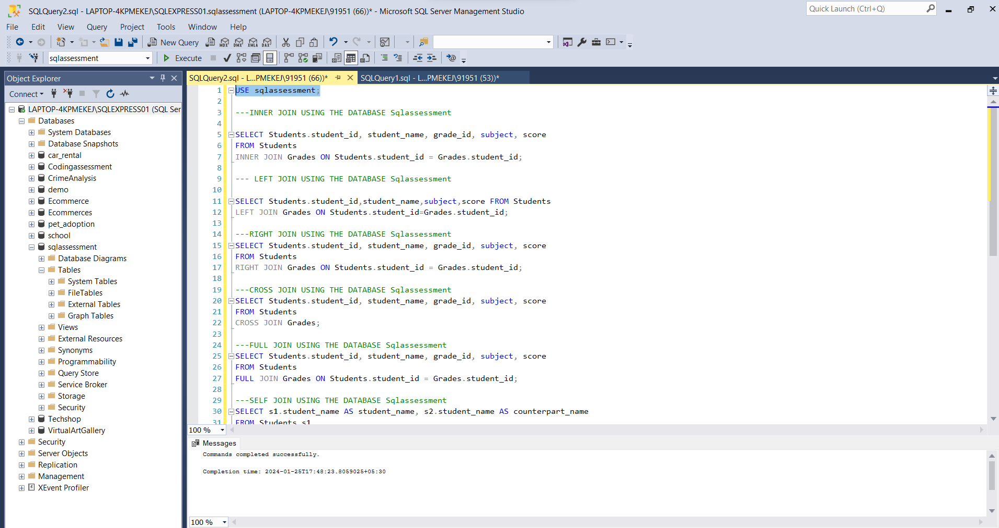

**STEP 2: PERFORMING INNER JOIN USING THE DATA**

Inner Join: An inner join in SQL is like combining information from two tables based on a

shared condition. It only includes rows where there is a match between the specified

columns in both tables. It is like putting together puzzle pieces that fit.

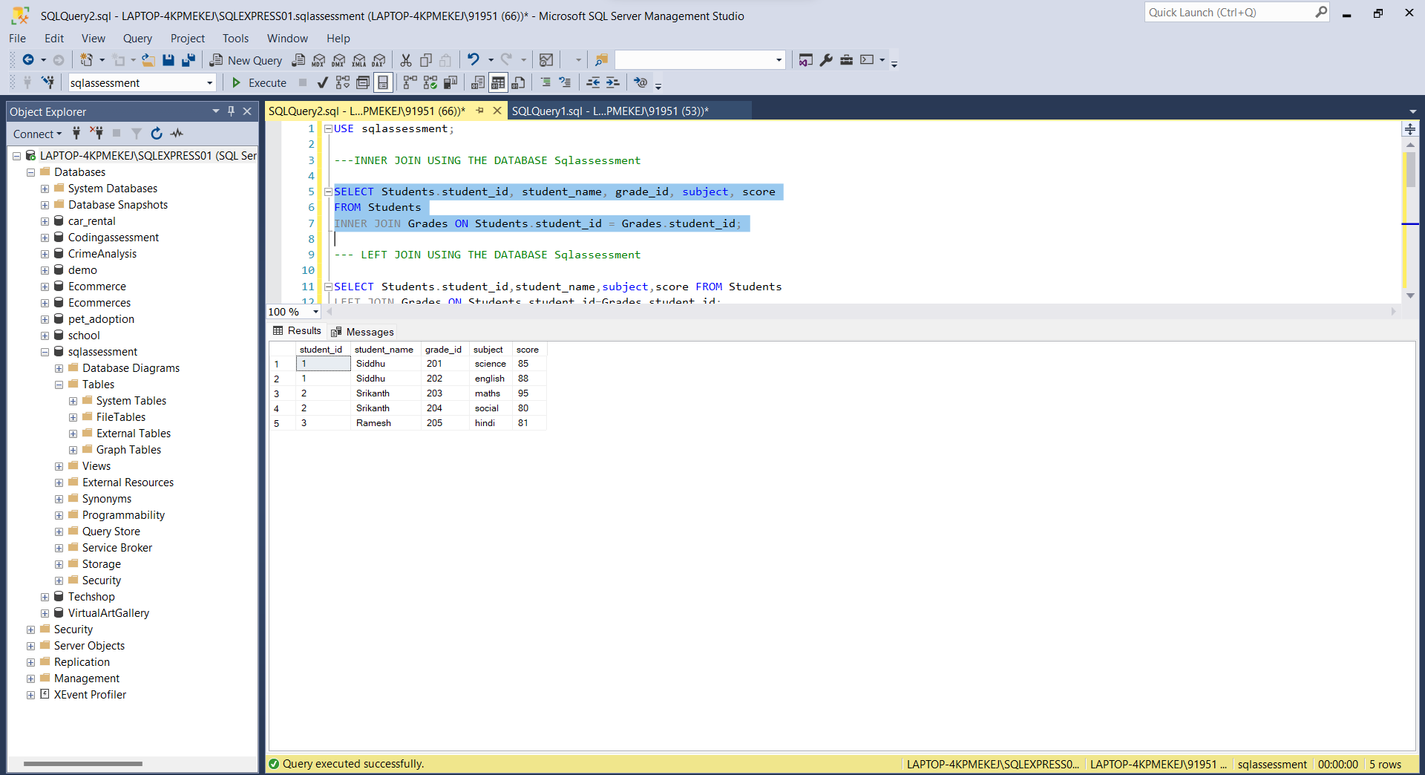

STEP 3 : PERFORMING LEFT JOIN USING THE DATA

Left Join: A left join in SQL is like showing all the rows from the left table and matching

rows from the right table. If there is no match in the right table, you still get the rows from the

left table, but with NULL values in the columns from the right table.

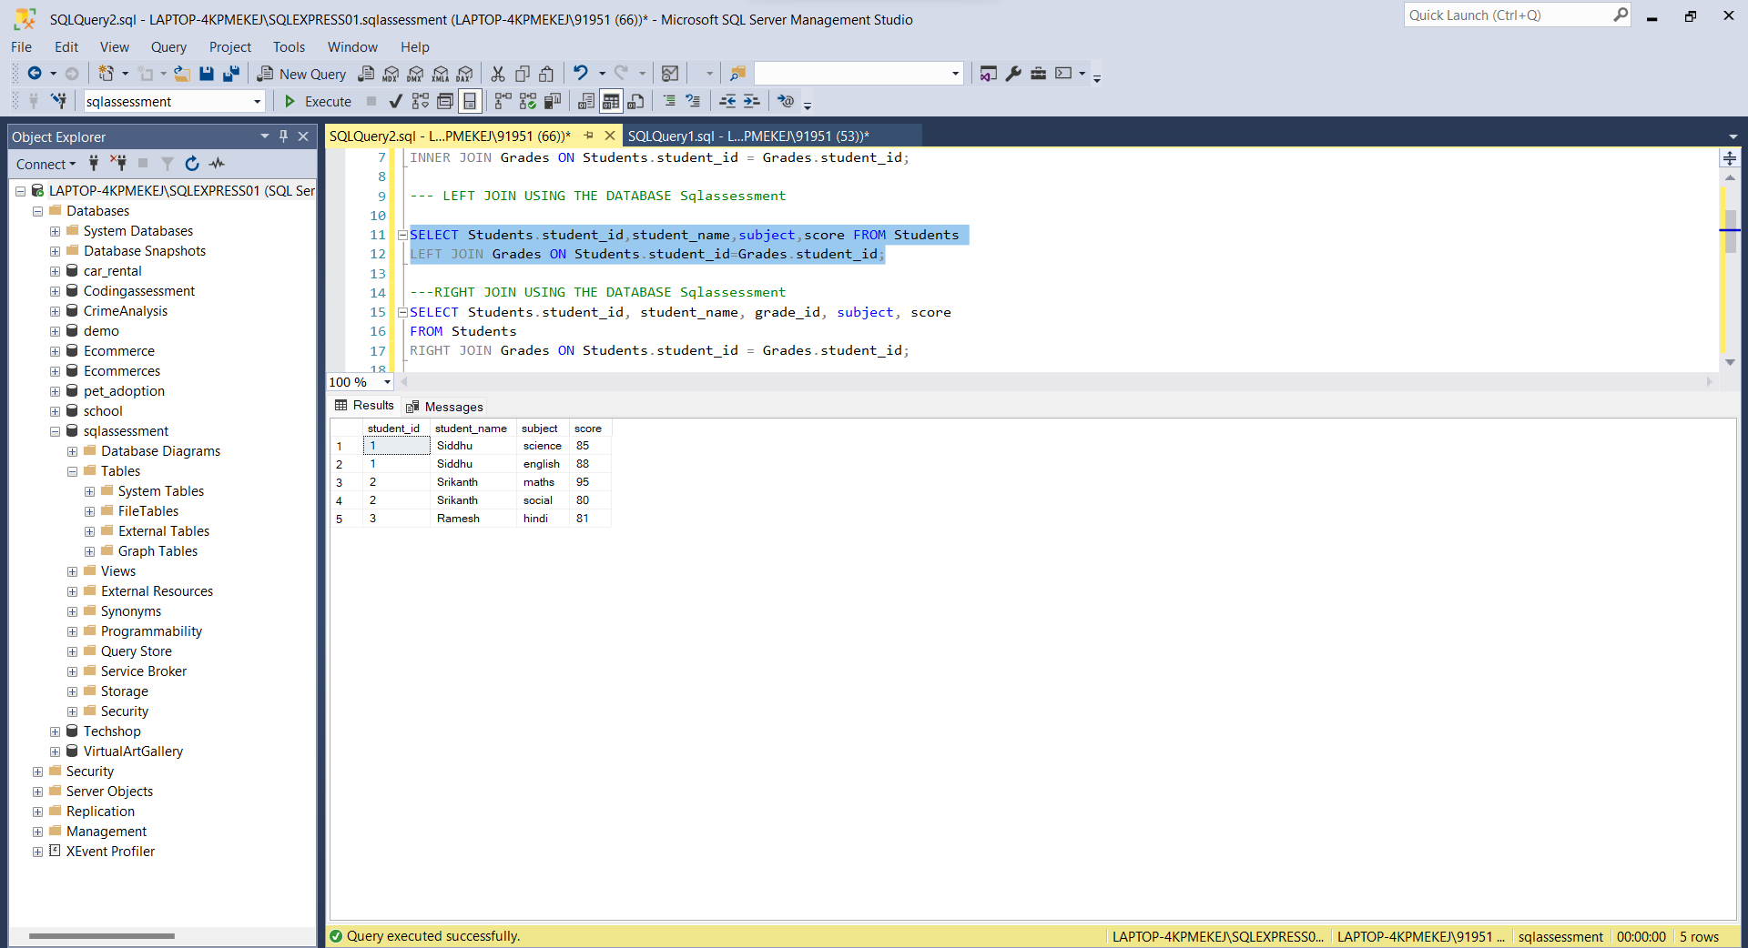

STEP 4: PERFORMING RIGHT JOIN USING THE DATA

Right Join: In a right join in SQL, all the rows from the right table and the matching rows

from the left table are included in the result. If there is no match, the result will still show all

the rows from the right table, and the columns from the left table will have NULL values.

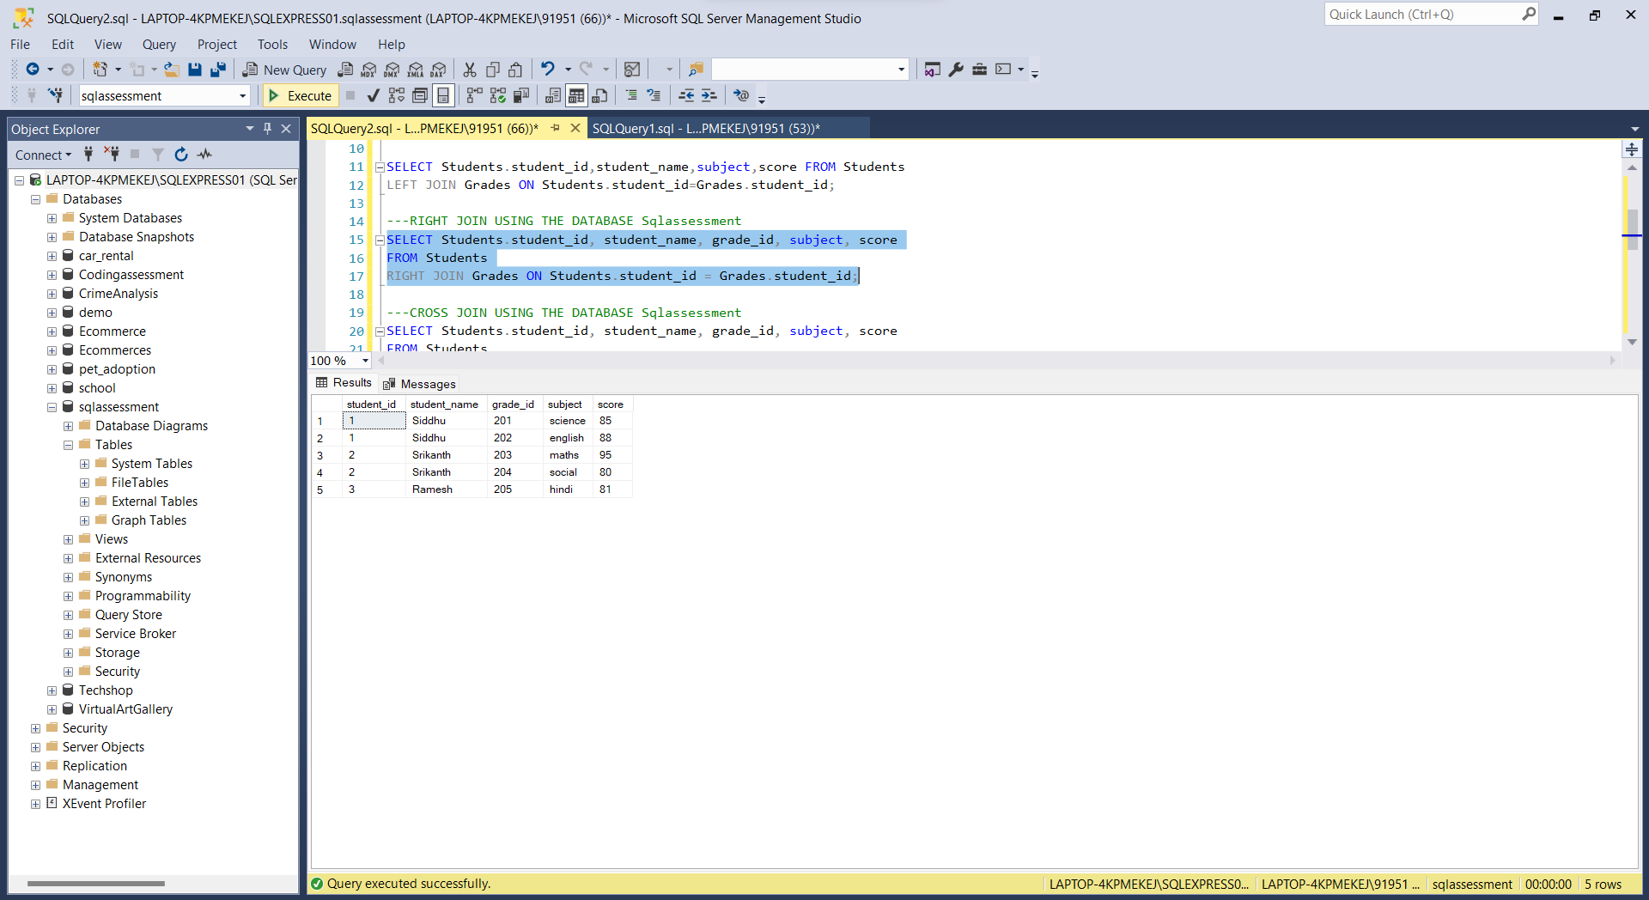

STEP 5: PERFORMING CROSS JOIN USING THE DATA

Cross Join: it forms all possible combinations of rows between the two tables.

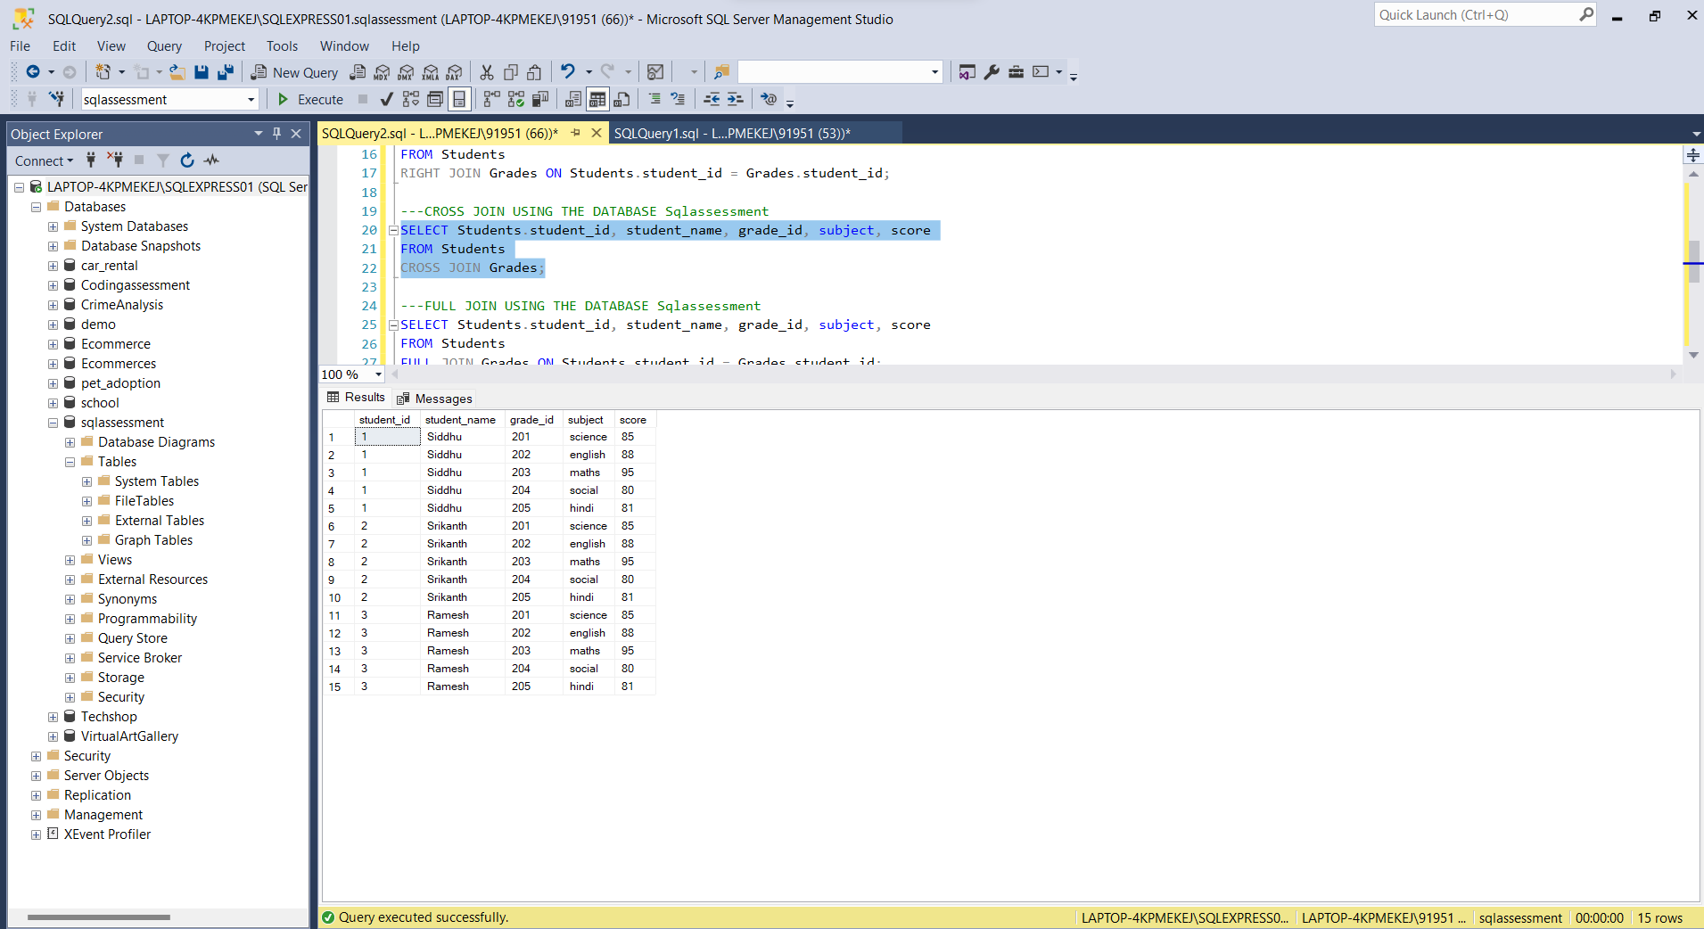

STEP 6: PERFORMING FULL JOIN USING THE DATA

Full Join: A full join in SQL is a type of join that returns all rows from both tables being joined, whether or not there is a match between the columns specified in the join condition.

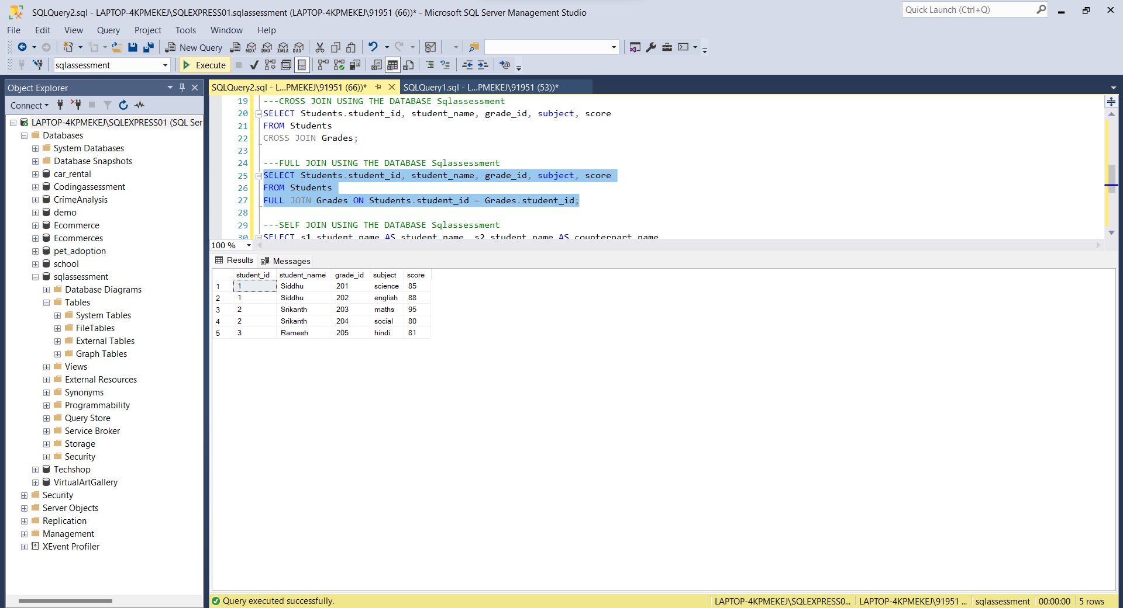

STEP 7: PERFORMING SELF JOIN USING THE DATA

Self Join: A self-join in SQL occurs when a table is joined with itself.

